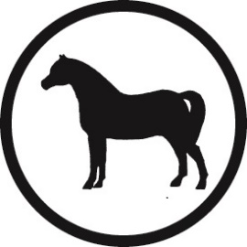
Welsh Pony & Cob Society
Young Judge’s Competition 2022

Saturday 6th August 2022 at 2.30pm
Three Counties Show Ground

Entry Form

The Young Judge’s competition is open to all young people aged between 10 and 25 years of age.

Area Associations and Overseas Societies are invited to enter teams and/or individuals. Each team will comprise of 3 individuals.

Entries are also invited from individuals who are not members of an area association, or whose association are not participating in the scheme.

Entries must be received no later than 22nd July 2022. Entry fee - FREE

Name of organisation or parent/guardian entering competitor(s):

...........................................................................................................................................................

Contact person for the organisation or parent/guardian:

Name
Address
Telephone number(s)
Email address

Signed : ......................................................................

Completed entry form should be forwarded no later than 22nd July 2022 to:
Gemma Bassett-Burr, Welsh Pony Cob Society, Bronaeron, Felinfach, Lampeter. SA48 8AG

Names of nominated competitors: * Age at the 1st January 2022

Name of competitor | Age* | Team Name (if applicable) | Address

